Question 1: Nested Tables

<!DOCTYPE html>

<html lang="en">

<head>

    <meta charset="UTF-8">

    <meta name="viewport" content="width=device-width, initial-scale=1.0">

    <title>Nested Table Document</title>

    <style>

        #main-table{

*text-align*:center;

*border-width*:4pt;

*border-style*:solid;

*border-color*: red;

        }

        th{

*text-align*:center;

        }

        #cell1, #cell2, #cell3, #cell4{

*border-color*:red;

*border-style*: solid;

*border-width*:1pt;

*padding*:1em;

        }

        img{

*width*:200px;

*height*:200px;

        }

    </style>

</head>

<body>

    <table id="main-table">

        <tr id="row1">

            <td class="col1" id="cell1">

                <h3>Nested Table 1</h3>

                <table id="nested-table">

                    <tr>

                        <th colspan="1">Column 1</th>

                        <th colspan="1">Column 2</th>

                    </tr>

                    <tr><td colspan="2"><h4> Our First Table Nested Within</h4></td></tr>

                </table>

            </td>

            <td class="col2" id="cell2">

                <h3> Nested Table 2</h3>

                <ul>

                    <li>List Item 1</li>

                    <li>List Item 2</li>

                    <li>List Item 3</li>

                </ul>

            </td>

        </tr>

        <tr id="row2">

            <td class="col1" id="cell3">

                <h3>Nested Table 3</h3>

                <a href="https://www.w3schools.com/html/tryit.asp?filename=tryhtml_table_elements">Nested Table</a><span> Demo Continued</span>

            </td>

            <td class="col2" id="cell4" >

                <h3>Nested Table 4</h3>

                <img src="Data/htmlpic.jpg" alt="htmlpic">

            </td>

        </tr>

    </table>

</body>

</html>

OUTPUT:

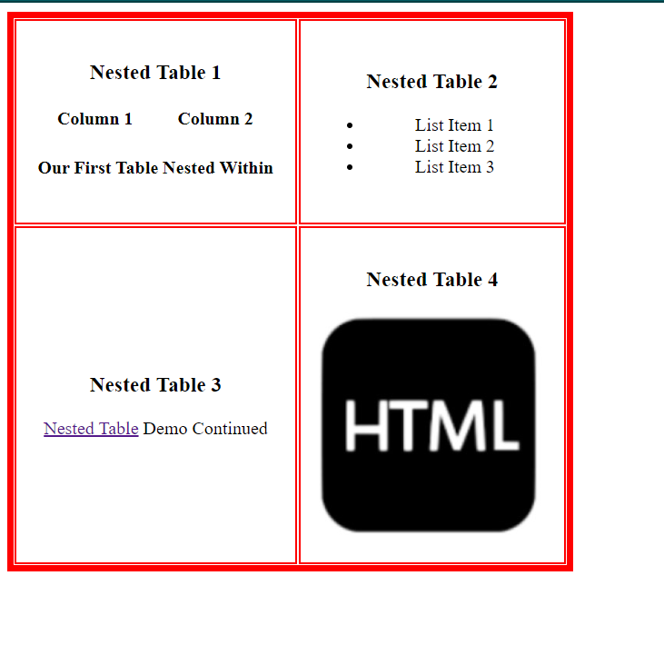

Github Link: [Link](https://github.com/anjali-rgpt/ncp-files-frames-and-forms/blob/master/nestedtables.html)

Question 3: Image Map

Code:

<!DOCTYPE html>

<html lang="en">

<head>

    <meta charset="UTF-8">

    <meta name="viewport" content="width=device-width, initial-scale=1.0">

    <title>Computer System</title>

    <style>

        body{

*text-align*: center;

        }

    </style>

</head>

<body>

    <img src="Data/computersystemraw.JPG" alt="computer system" usemap="#comp">

    <map name="comp">

        <area shape="rect" coords="49,77,212,171" href="Additional/printer.html" alt="printer-pic" />

        <area shape="rect" coords="226,40,399,189" href=" Additional/monitor.html" alt="monitor-pic" />

        <area shape="rect" coords="409,68,485,200" href=" Additional/cpu.html" alt="cpu-pic" />

        <area shape="rect" coords="206,195,288,250" href=" Additional/speakers.html" alt="speakers-pic" />

        <area shape="rect" coords="302,213,553,229" href=" Additional/keyboard.html" alt="keyboard-pic" />

        <area shape="rect" coords="454,241,515,254" href=" Additional/mouse.html" alt="mouse-pic" />

    </map>

</body>

</html>

Sample redirected page code:

<!DOCTYPE html>

<html lang="en">

<head>

    <meta charset="UTF-8">

    <meta name="viewport" content="width=device-width, initial-scale=1.0">

    <title>Speakers</title>

</head>

<body>

    <h1>Speakers</h1>

    <p>Computer speakers, or multimedia speakers, are speakers sold for use with computers, although usually capable of other audio uses, such as augmenting music amplitude from music devices and other sources of sound. </p>

</body>

</html>

Output:

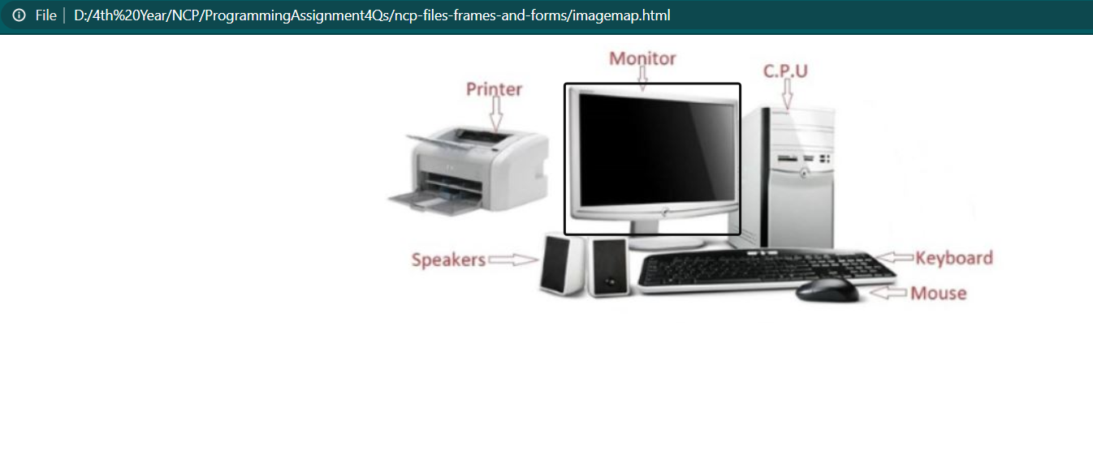

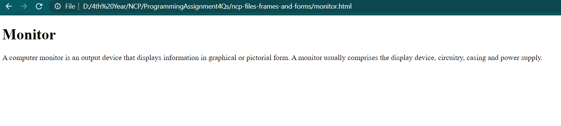

GitHub Link: [Link](https://github.com/anjali-rgpt/ncp-files-frames-and-forms/blob/master/imagemap.html)

Question 4: Frames and Forms

<!DOCTYPE html>

<html lang="en">

<head>

    <meta charset="UTF-8">

    <meta name="viewport" content="width=device-width, initial-scale=1.0">

    <title>Application Form</title>

    <style>

        .form-frame {

*background-color*: lavenderblush;

*display*: flex;

*justify-content*: space-evenly;

        }

        .form-frame>div {

*float*: left;

*margin*: 10px;

        }

        .req {

*color*: red;

        }

        .section {

*border-color*: rebeccapurple;

*border-width*: 2pt;

*border-style*: solid;

*text-align*: center;

        }

        #fax {

*float*: right;

        }

    </style>

</head>

<body>

    <form method="POST" action="http://google.co.in">

        <frameset rows="25%, 25%, 25%, *">

            <frame src="Additional/form1.html" />

            <frame src="Additional/form2.html">

                <frame src="Additional/form3.html"></frame>

                <frame></frame>

        </frameset>

        <div class="section">

            <div class="form-frame">

                <div id="document-type">

                    <input type="radio" name="document" value="Id" /><label>Id </label>

                    <input type="radio" name="document" value="Passport" /><label>Passport </label>

                </div>

                <div>

                    <label> Number:</label>

                    <input type="text" name="idnum">

                </div>

                <div>

                    <label>Passport Expiration Date:</label>

                    <input type="date" name="expdate">

                </div>

                <div>

                    <label>Passport Country:</label>

                    <select name="country">

                        <option value="---" selected>---</option>

                        <option value="India">India</option>

                        <option value="Barbados">Barbados</option>

                        <option value="USA">United States of America</option>

                    </select>

                </div>

            </div>

        </div>

        <div class="section">

            <div class="form-frame">

                <div>

                    <label>Title:</label>

                    <select name="title">

                        <option value="Dr." selected="selected">Dr.</option>

                        <option value="Mr.">Mr.</option>

                        <option value="Miss">Miss</option>

                        <option value="Ms.">Ms.</option>

                        <option value="Mx.">Mx.</option>

                    </select>

                </div>

                <div>

                    <label class="req">First Name</label>

                    <input type="text" name="fname">

                </div>

                <div>

                    <label class="req">Last Name</label>

                    <input type="text" name="lname">

                </div>

            </div>

            <div class="form-frame">

                <div>

                    <label>Demo Card ID:</label>

                    <input type="text" name="dcid">

                </div>

                <div>

                    <label>Company Card No.</label>

                    <input type="text" name="ccno">

                </div>

                <div>

                    <label>Birth Date</label>

                    <input type="date" name="dob">

                </div>

            </div>

        </div>

        <div class="section">

            <div class="form-frame">

                <div>

                    <label>License Country:</label>

                    <select name="lic">

                        <option value="---" selected="---">Dr.</option>

                        <option value="India">India</option>

                        <option value="Barbados">Barbados</option>

                        <option value="USA">United States of America</option>

                    </select>

                </div>

                <div>

                    <label>Issue Date</label>

                    <input type="date" name="idate">

                </div>

                <div>

                    <label>IATA</label>

                    <input type="text" name="iata">

                </div>

            </div>

            <div class="form-frame">

                <div>

                    <label>Driver License Number:</label>

                    <input type="text" name="driver">

                </div>

                <div>

                    <div>

                        <label>Expiry Date</label>

                        <input type="date" name="edate">

                    </div>

                </div>

                <div>

                    <label>Phone 1</label>

                    <input type="text" name="p1">

                </div>

            </div>

            <div class="form-frame">

                <div>

                    <label>Address:</label>

                    <textarea name="address"></textarea>

                </div>

                <div>

                    <div>

                        <label>Phone 2</label>

                        <input type="text" name="p2">

                    </div>

                </div>

            </div>

            <div id="fax" class="form-frame">

                <label>Fax 1</label>

                <input type="text" name="fax1">

            </div>

        </div>

        <div class="section">

            <input type="submit"/>

            <input type="reset">

        </div>

    </form>

</body>

</html>

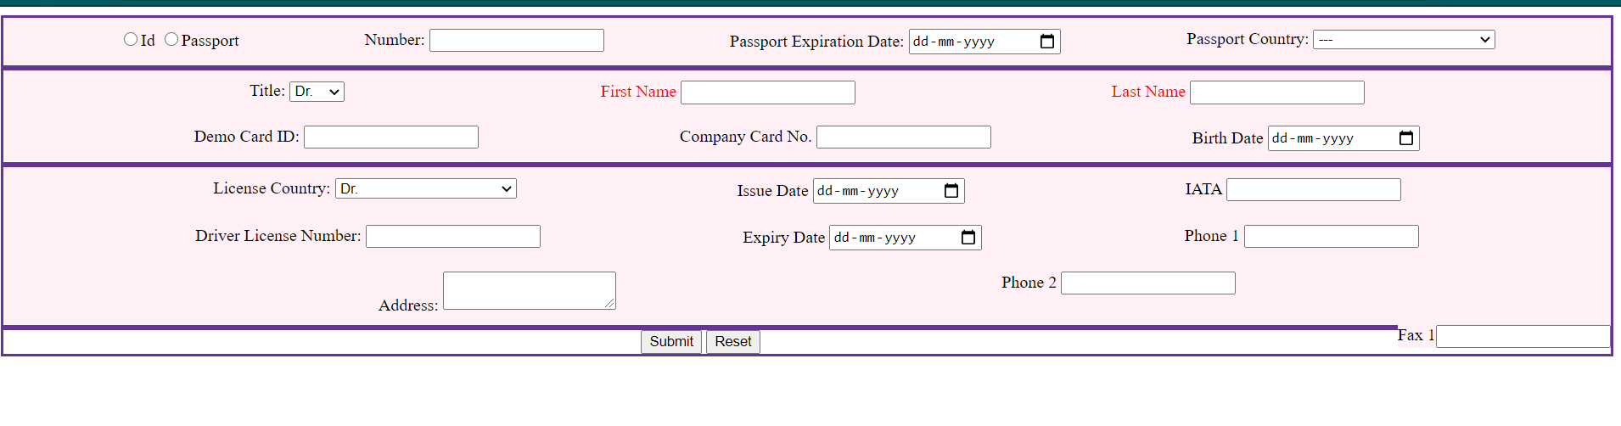

Github Link:[Form Link](https://github.com/anjali-rgpt/ncp-files-frames-and-forms/blob/master/bigform.html)

Question 2: In Progress – Time Table

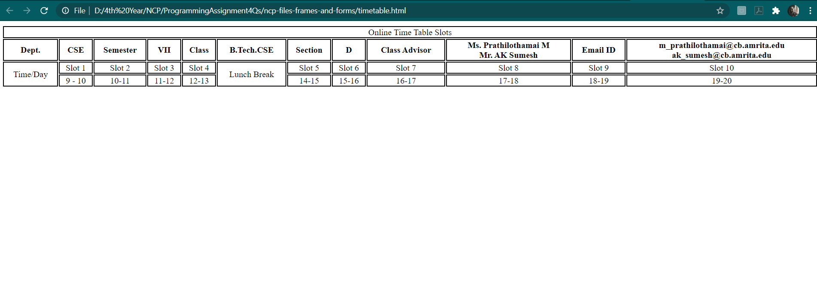

<!DOCTYPE html>

<html lang="en">

<head>

    <meta charset="UTF-8">

    <meta name="viewport" content="width=device-width, initial-scale=1.0">

    <title>Time Table</title>

    <style>

        td, th{

*text-align*: center;

*border-style*:solid;

*border-width*: 1pt;

*border-color*:black;

        }

        table{

*width*:100%;

        }

    </style>

</head>

<body>

    <table>

        <tr >

            <td colspan="12">Online Time Table Slots</td>

        </tr>

        <tr>

<th colspan="1">Dept.</th>

<th colspan="1">CSE</th>

<th colspan="1">Semester</th>

<th colspan="1">VII</th>

<th colspan="1">Class</th>

<th colspan="1">B.Tech.CSE</th>

<th colspan="1">Section</th>

<th colspan="1">D</th>

<th colspan="1">Class Advisor</th>

<th colspan="1"><div>Ms. Prathilothamai M</div><div>Mr. AK Sumesh</div></th>

<th colspan="1">Email ID</th>

<th colspan="1"><div>m_prathilothamai@cb.amrita.edu</div><div>ak_sumesh@cb.amrita.edu</div></th>

        </tr>

        <tr>

            <td rowspan="2">Time/Day</td>

            <td>Slot 1</td>

            <td>Slot 2</td>

            <td>Slot 3</td>

            <td>Slot 4</td>

            <td rowspan="8">Lunch Break</td>

            <td>Slot 5</td>

            <td>Slot 6</td>

            <td>Slot 7</td>

            <td>Slot 8</td>

            <td>Slot 9</td>

            <td>Slot 10</td>

        </tr>

        <tr>

            <td>9 - 10</td>

            <td>10-11</td>

            <td>11-12</td>

            <td>12-13</td>

            <td>14-15</td>

            <td>15-16</td>

            <td>16-17</td>

            <td>17-18</td>

            <td>18-19</td>

            <td>19-20</td>

        </tr>

    </table>

</body>

</html>

Link: <https://github.com/anjali-rgpt/ncp-files-frames-and-forms/blob/master/timetable.html>